**Why buy Precious Metals?**

Since historical time, precious metals like Gold, and Silver have been a part of the economic aspects of life. Gold and Silver are synonymous with wealth generation and wellbeing, which is why they adorned the crowns of kings and queens. Nations used Gold and Silver coins as currency for centuries. In the 21st century, modern **investors buy precious metals** to store and build wealth.

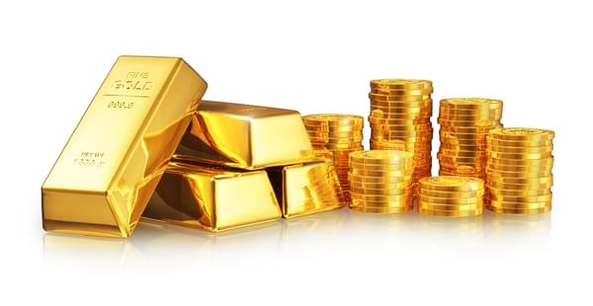

**Key takeaways**

* Investing in precious metals may be a stable and safe way to store and create wealth.
* Rising Gold and Silver prices may offer significant gains for profit-minded investors.
* Investing in Precious Metals can diversify your portfolio and reduce risks.
* Precious metals have intrinsic value and high demand, ideal for long-term investments.

**How do precious metals diversify your portfolio and reduce risks?**

Most investors focus on either stock markets, real estate, bonds, or other traditional investments. But these options come with significant risks. In the past 20 years, millions of people across North America have lost their investments to economic turmoil. Precious metals have unique qualities that set them apart from other commodities and assets. When you invest in Gold or Silver, you don’t have to worry about counterparty risks such as devaluation, saturation, volatility, and boom-and-bust cycles. However, most people don’t consider buying Precious Metals when choosing investment opportunities.

To help you make informed investment decisions, here are the main reasons why you should buy precious metals.

**Top five reasons why you should invest in precious metals**

**1. Safe haven against declining Dollar**

Investors have relied on Gold as a “safe haven” in times of economic turmoil for centuries. In the 21st-century economy, the declining US dollar can keep any investor nervous. The value of the US dollar against other currencies has far-reaching implications for American investors. Over the last two decades, US stocks delivered better gains when the US dollar was strong than when it is weak.

Source: <https://www.marketwatch.com/story/what-a-falling-dollar-could-do-to-the-stock-market-2020-02-21>

Betting all your resources and financial future only on paper assets is a recipe for disaster. The adage “don’t put all your eggs in one basket” comes to mind. The bottom line? If you’re worried about the declining US dollar, diversify your portfolio. Unlike stocks, bonds, and mutual funds, the price of [Gold](https://goldln.arhamsoft.info/products/canadian-gold-maple-leaf-1-2-oz) likely rises the most in trying times. Investing in precious metals is an effective way to diversify your portfolio. As an investor, you can rely on Gold as a safe haven against the declining US dollar.

**2. Safe way to grow Wealth during Uncertain Economic Times**

Since 2000, American investors have lost money to the dot-com bubble burst, the stock market crash, and the [2009 housing bubble burst](https://www.investopedia.com/terms/h/housing_bubble.asp). But Gold and Silver remained relatively stable during this period. In 2020, Gold outperformed most traded assets.

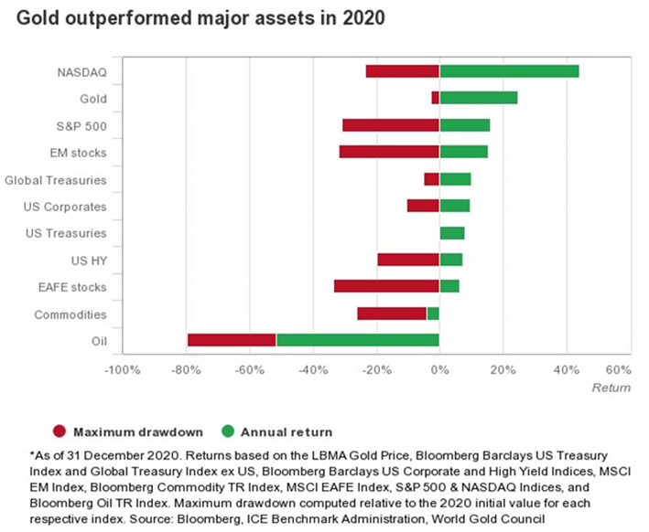

Source: [https://www.mining.com/Gold-investment-demand-remains-well-supported-in-2021-report/](https://www.mining.com/gold-investment-demand-remains-well-supported-in-2021-report/)

In these uncertain times, **investing in Gold and Silver** offers higher stability and growth than other assets. As an investor, **buying precious metals** is the safest way to hedge against economic calamity.

**3. Rising Gold and Silver prices**

Historically, the stock market was the go-to option for high, short-term profit gains. But stocks have become increasingly volatile and unpredictable in the past decade. From 2005 to 2020, Gold prices [increased by 330%](https://www.investopedia.com/ask/answers/020915/has-gold-been-good-investment-over-long-term.asp), while the DJIA rose by only 153%. In August 2020, Gold price reached a historical high of [$2,067 per ounce](https://www.mining.com/gold-price-rally-stretches-towards-2050/). Buying Gold offers a long-term investment without the volatility of the stock markets.

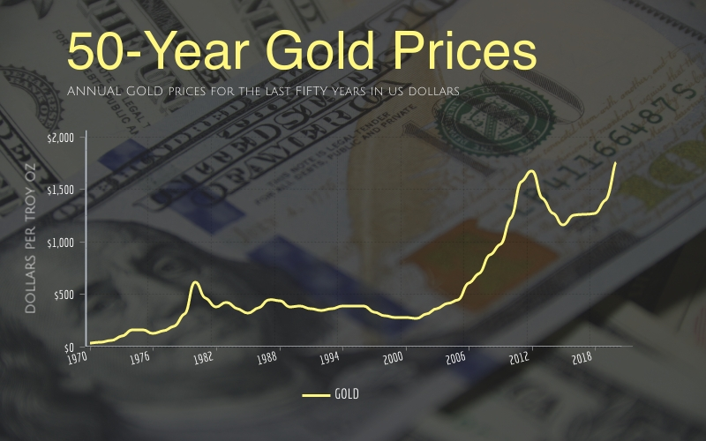

Source: [https://www.gainesvillecoins.com/blog/Gold-price-history](https://www.gainesvillecoins.com/blog/gold-price-history)

The Silver price has more than doubled in the past five years. In 2016, Silver was $14/ounce. It increased to $18 within a year and reached close to $20 by 2019. In July 2021, Silver prices surged past $28. It is not too late to get on this profitable train. Gold and Silver prices may rise further in 2021 as more investors buy these precious metals to hedge against economic turmoil. Now maybe the best time to **invest in Gold and Silver**!

**4. Hedge against inflation**

Precious metals are rare commodities with intrinsic value, which guarantees demand regardless of the prevailing economic situation. In 2021, governments are increasing spending to jump-start their economies. Gold keeps up with the money supply but performs better amid high inflation. Gold's prices increase by 15% on average when inflation is higher than 3%.

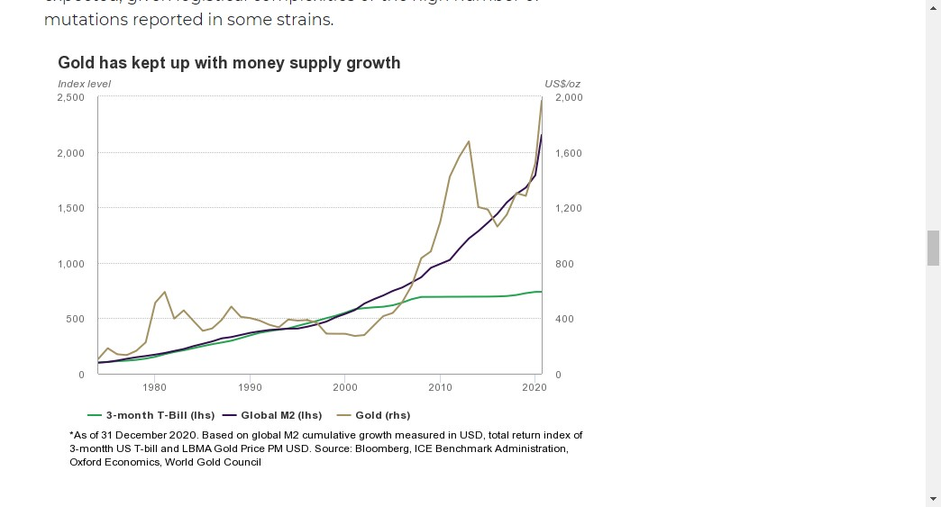

Source: [https://www.mining.com/Gold-investment-demand-remains-well-supported-in-2021-report/](https://www.mining.com/gold-investment-demand-remains-well-supported-in-2021-report/)

Unlike other investments, no one can build or print more Gold and saturate the market. Banks can invest more in the real estate market, increase supply, and devalue your property investment within a few months. When you **invest in Gold**, you don’t have to worry about market saturation and asset devaluation. Increased demand for Gold leads to higher prices. According to World Gold Council’s [2021 outlook report](https://www.gold.org/goldhub/research/outlook-2021), investment demand for Gold will remain high throughout the year. To exploit this fast-growing investment opportunity, **buy Gold today**!

**5. Increasing use cases and value**

Although Gold and Silver are synonymous with high-end jewelry, they have multiple use cases. Both Gold and Silver have [high electrical conductivity](https://monroeengineering.com/blog/why-gold-is-used-in-electronics/), ideal for circuit boards. They are used in modern industrial processes to manufacture electronics, including computers, smartphones, TVs, and video game consoles.



In the healthcare sector, medical practitioners use Gold to treat lagophthalmos and other medical conditions. The value of Gold, Silver, and Platinum will likely increase in the future as technological innovations create new use cases. Buying precious metals is a smart and maybe profitable long-term investment.

To experience all the benefits of buying precious metals, invest with a reputable dealer like Goldline.

[Goldline](https://goldln.arhamsoft.info/) has over 60 years of experience in the precious metals sector. You can rely on Goldline to buy Gold and Platinum coins or [Silver bars](https://goldln.arhamsoft.info/products/silver-bar-10oz). With Goldline’s [Accumulation Program](https://goldln.arhamsoft.info/accumulation), investors can acquire precious metals for as little as $200 per month, per product. To invest in precious metals with a reliable partner, [contact us](https://goldln.arhamsoft.info/pages/contact-us) today!

**Meta Description**

Why should you invest in precious metals? Buying Gold, Silver, or Platinum is a safer, stable, and profitable investment opportunity. Read more to diversify your portfolio and reduce risks.